Name(s) ______________________________________________________

The Case of the Crying Baby
Part I - Is this Normal?

Sara and Matt had a loving relationship and successful careers. With the birth of their daughter Kayla they felt their lives were complete. Kayla was a thriving¹, beautiful, fair skinned baby with sparkling blue eyes. Within the first few weeks of life she grew at an astonishing rate, developing the gentle, soft curves that make babies so lovable. Then suddenly the fairytale existence of the new family abruptly ended.

By the time Kayla was six weeks old her eyes were continually filled with tears. She cried throughout the day and most of the night. Kayla began to run intermittent² fevers and Sara noticed that she had a lump that would periodically bulge from her groin. Motrin and Tylenol seemed to take care of the problem. Despite the use of cloth diapers and meticulous cleaning, Kayla also developed a raw redness and peculiar rash. Sara repeatedly called the pediatric nurse but she seemed to act as if Sara was just being an overly anxious new mother.
The physician, Dr. James, was not much more concerned. “I think it’s important for you to get back to work, so you have more diversity in your life. Kayla’s crying is most likely the result of colic³ causing her to experience indigestion. The rash is probably simply from not changing Kayla’s diapers enough. You may want to try some A&D ointment.”

Sara felt totally inadequate as a mother and vowed to do all she could to meet the needs of her daughter.
Sara began a bland, but balanced diet and routinely changed Kayla’s diaper every 30 to 60 minutes throughout the day. Sara noticed that her daughter’s diapers were never soaked and often were coated with a thick yellowish discharge⁴. This too was brushed off by one of the group pediatricians as probably due to a normal vaginal discharge caused by the withdrawal of maternal estrogen stimulation. When Kayla continued to cry and the rash worsened, Sara again called the doctor’s office.
“Continue to use the A&D and leave Kayla diaper-less for several hours a day,” the nurse advised.

Again Sara obliged. Kayla’s crying worsened and even her seasoned⁵ grandmothers were reluctant to hold or watch her. Sara decided to postpone returning to work for a year so that she could take care of Kayla.

By the time Kayla was three months old both she and Sara looked haggard⁶. The constant crying and sleepless nights had taken a toll on them. Matt insisted that they go to see the doctor. Kayla was no longer gaining weight or growing, and the groin bulge was now prominent enough for the doctor to acknowledge an inguinal hernia. Sara and Matt felt relieved, believing that this was the source of their daughter’s problems and the end to a nightmare existence, though they were worried about their daughter needing surgery.

“This type of surgery is routine,” Dr. Broward, the surgeon, said reassuringly. “It’s a simple, uncomplicated repair. When Kayla recovers she will feel much more comfortable.” The surgery went without incident and Kayla came home the next day, but the crying continued. In fact, if anything, she seemed worse than before the surgery and now she was hardly taking in any nourishment. Sara found that again Kayla was running a fever. She called the pediatrician, who advised her to call the surgeon. The surgeon felt that Sara was probably holding her too much and that the fever was unrelated to the surgery.

Sara was finally convinced by her mother that she needed to see a different doctor for a second opinion, so she found a doctor in a nearby town and managed to get an appointment. By this time Kayla’s fever was climbing and her once pale skin was now a bright red. In the waiting room, another mother made a comment to Sara, “you should really keep your baby protected from the sun.” Sara again felt victimized and began to wonder if she would ever find anyone able to determine the cause of Kayla’s problems.

Questions

1. What symptoms has Kayla exhibited over the first months of her life?

2. What treatments were suggested by the nurses and physicians when the symptoms first appeared?

3. What is a hernia and why would this have been the source of Kayla's medical problems?

4. What was Sara feeling “victimized” by the ordeal?

5. For each of the underlined and numbered words in Part 1, suggest a short definition based on the context. If you are really stuck, you can google a definition but try to put it in your own words.

Part II – What’s Really Wrong with Kayla?

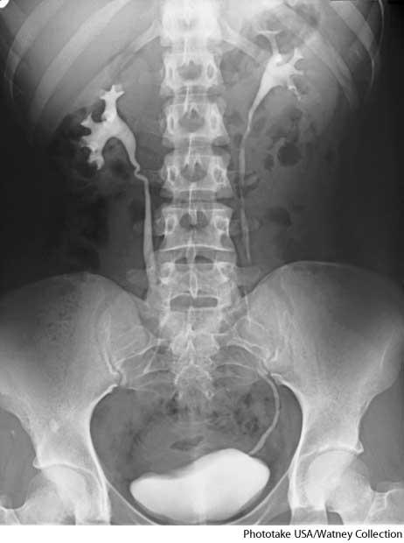
At the new office, the nurse weighed and measured Kayla, then took her temperature and reviewed her symptoms with Sara. Doctor Hubble then came in to check Kayla. He had completed an internship and some research in pediatric urology and immediately recognized the symptoms. He requested a urine sample, which was successfully accomplished with a catheter⁷, a procedure that was very uncomfortable for both Kayla and Sara. The specimen was loaded with pus and blood cells.

“I think that in light of the urinary tract infection, Kayla should immediately begin an antibiotic,” said Dr. Hubble. “She also needs a VCUG⁸. This is a voiding cystourethrogram is an X-ray test that takes pictures of your bladder and urethra while your bladder is full and while you are urinating.

The doctor also ordered an IVP⁸, or an intravenous pyelogram, used to detect anatomic abnormalities. This X-ray image would show the kidneys, bladder, and ureters.

By the end of the week both tests had been completed and Sara, Matt, and Kayla were back at the pediatrician’s office for a consultation. The tests had revealed a diagnosis of bilateral duplicate collection systems (four ureters instead of the usual two), hydronephrosis (urine collecting in the kidney pelvis), and grades four and five reflux (urine doesn’t empty normally and backs up into the kidneys). Kayla’s kidney function was markedly decreased on the right and partially limited on the left.

“I feel that you need to take Kayla to a specialist,” Doctor Hubble advised. “I recommend Dr. Leftt, a surgeon who is an expert in pediatric urology. I also want you to be aware that within the pediatric urology community there is some disagreement on the course of treatment—medical versus surgical management. You may also want to consult with Dr. Wright. He’s equally as competent, but will most likely take a medical view of how Kayla should be managed. Perhaps you should meet with both doctors before making a decision. Right now I think Kayla should have a daily antibiotic to prevent further infections and damage to her kidneys.”

Questions

6. Three medical procedures are mentioned in this section (numbered above.) Explain the purpose of each of the procedures.

7. The pediatrician suggested that Dr. Wright and Dr. Leftt would have differing viewpoints on how to treat Kayla. How will their opinions differ based on Dr. Hubble’s warning here?

7. View a diagram showing a normal kidney with the location of the ureters, bladder. Sketch how Kayla's urinary system looks in comparison. →

Part III - How Should Kayla Be Treated?

Dr. Leftt asked Sara and Matt to sit down as he pulled out Kayla’s x-rays and explained that the four bulging tubes attached to odd-shaped masses were Kayla’s ureters and kidneys. He advised that the only course of treatment was surgery to move all four ureters higher into the bladder and the creation of a flap valve apparatus to prevent urine from reversing into the kidneys.

“The surgery is not risk free,” Dr. Leftt emphasized, “but without it Kayla’s kidneys may suffer irreversible damage. The severity of the reflux will be reduced, but not eliminated. This allows for growth, but leaves a continued risk of infection. Kayla will need to continue antibiotics, initially be monitored weekly and have periodic tests for several years until her urinary system functions normally.

Dr. Leftt had a kind but firm approach. He reviewed the number of surgeries he had done and advised that the surgery would take four to six hours, and Kayla would be in intensive care for two days followed by a week of hospitalization. If Sara and Matt opted out of surgery, Dr. Leftt felt that there was a good chance that Kayla’s kidneys would fail within a year. Dr. Leftt suggested the family should seek a second opinion before deciding on a course of treatment.

A few days later Sara and Matt met with Dr. Wright. Again the findings and x-rays were reviewed. Dr. Wright felt that there was no urgency to treat Kayla surgically. He explained some children had been successfully treated with long-term prophylactic use of antibiotics. “Some children like Kayla,” Dr. Wright gently explained, “will outgrow the reflux as their bladder grows. It’s foolish to rush into a surgical procedure with all the inherent complications if the infections can be managed medically.”

He reassured Sara and Matt that weekly urinalysis and periodic VCUGs would allow them to closely monitor the functioning of the kidneys. Dr. Wright ended by saying that if the reflux persisted beyond the age of eight, Kayla would then require surgery. Sara and Matt felt confused by the different recommendations proposed by Dr. Leftt and Dr. Wright.

8. This section has no vocabulary words identified. Find 2 terms you think some people might have trouble with and highlight or underline them. Annotate a short definition or description for the words.

9. Describe the surgery that would be used to treat Kayla's condition. What are the risks of the surgery?

10. On treatment suggested long-term prophylactic use of antibiotics. What does this mean?

11. If you were Kayla's parents, which treatment option would you choose and why. Defend your choice
with evidence based reasoning from this case study. Attach page if necessary.

