/40 Marks Name:______________________
Partners:__________________
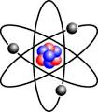Project #1: Element Con 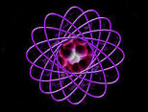
BC Connect 9: 2-C Page 118

My Element is: __________

/20 Information:
- Name, symbol, atomic number
- Origin of the element’s name and symbol
- Date of discovery
- How was it discovered?
- Physical properties of the element:
  - Melting point
  - Boiling point
  - Density
  - State at room temperature (21ºC)
  - Colour
  - Texture
  - Hardness/ softness
  - Odour
  - Ductile or malleable
  - Conducts electricity
- What is the group, family, and/or location of the element on the table?
- Where is the element found
  - In the world? Universe?
  - Is it found pure? Compounds?
  - What type of compounds does it make?
- How is the element used today and in the past?
- What is the economic importance of the element?
- Any other interesting facts (at least 5)

Be sure to write down at least three websites that you used as references:
1.
2.
3.
/20 Presentation

- Neatness: writing and/or typing
- Organization: images, presentation, story, video
- Spelling, Grammar
- Images
- Accuracy
- Presentation style
- Colourful
- Eye catching
- Professional
- WOW factor

