Biology 12: Prereading activity ANSWER KEY:
Chp.16. and Chp. 16.2

“U – R” ABOUT TO LEARN ABOUT THE:
URINARY SYSTEM
TASK: Read pages 304 to 309 and answer the following questions
- What are the primary organs of excretion?
- Kidneys

- Define excretion. How does excretion and defecation differ?
- The removal of metabolic waste.(urine)
- Defecation is the elimination of feces (digestive system)

- List and describe the four functions of the kidneys to maintain homeostasis.
- Excretion of metabolic waste: (urea, ammonium, creatine, and uric acid
- Maintain water/salt balance: (and blood pressure) by diffusion of water into the blood
- Maintain acid-base balance: excrete H+and reabsorb bicarbonate (HCO3-)
- Secretes hormones: assist endocrine system; adrenal gland secretes aldosterone and erythropoietin (RBC production)

- For each of the following organs, list the function and describe its structure:
Organ | Structure | Function
Kidney | Paired, towards back, either side of vertebrae, bean shaped, red brown colour, fist sized, surrounded by adipose tissue and capsule | Maintain water balance; removal of urea; removal of uric acid
Ureter | Small muscular tubes 25 cm long and 5 mm in diameter | Tubes that connect urine from kidneys to bladder
Urinary Bladder | Muscular organ (3 layers of muscles: two longitudinal middle layer is circular muscle) with 3 openings. Has rugae (folds in the mucosa) | Stores urine until expelled. Skeletal muscle sphincter (voluntary) control (200, 400, 600 mL: involuntary release
Urethra | Small tube extrends from bladder to opening. Males: 20 cm and connected to repro system. Females: 4 cm and not connected to repro system. | Removes urine from the body

- What is another name for Urination and describe this process.
Micturition: 250mL stretch receptors send nerve impulse to spinal cord causing bladder to contract and sphincters to relax. Voluntary in adults and older children.

- Draw a sketch of a cross section of a kidney and label the renal cortex, renal medulla, renal artery, renal vein and renal pelvis.

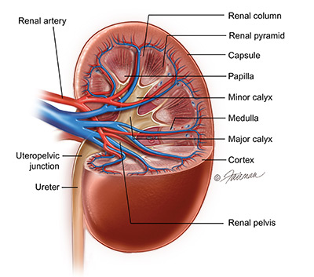

- Name 5 parts of a nephron and briefly describe their function.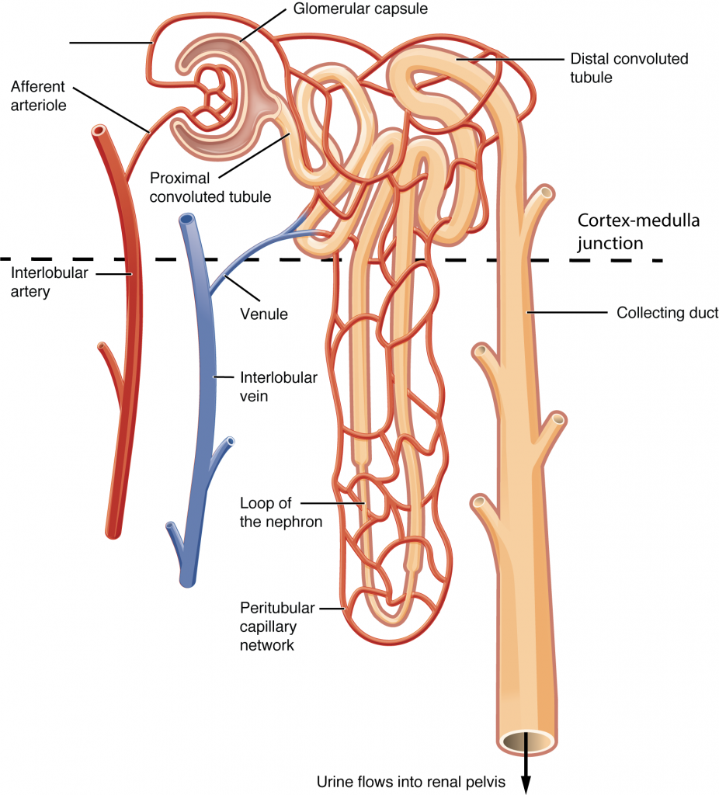
- Glomerular Capsule: (Bowman’s Capsule): Cuplike structure of nephron which receives filtered fluid from glomerulus via afferent arteriole via renal artery.
- PCT: proximal convoluted tubule: Glomerular reabsorption: microvilli increase absorption
- Loop of Henle: (loop of the nephron): Tubular reabsorption: water leaves via osmosis and Na and Cl
- DCT: Distal convoluted tubule: (lots of mitochondria but no microvilli) tubular secretion (move molecules from the blood into the tubule)
- Collecting Duct: carry urine to renal pelvis.

- What are the 3 stages of urine formation?
- Glomerular Filtration
- Tubular Reabsorption
- Tubular secretion

- What are the filterable components of the blood in the glomerulus?
Water, nitrogenous wastes, nutrients, salts (pass through capillary wall)

- What are the non-filterable components of the blood in the glomerulus?
Formed elements (blood cells and platelets); plasma proteins

- Why does tubular reabsorption have to occur?
- Water reabsorbed from nephron into the capillary network.
- Maintains osmoregularity of the blood (active transport: Na+ glucose and A.A) (passive: water moves from tubule into the blood)
- What is reabsorbed?
Water, sodium, glucose, urea (water, nutrients, required salts)

- What are 3 components that are not reabsorbed and continue to pass through the nephron to be further processed?
Some water, nitrogenous wastes, excess salts (ions)

- What molecules are added to the urine in tubular secretion?
(Secreted from peritubular capillary network into tubules): H+, K+ ions, creatine, and drugs (penicillin)

