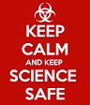 Safety Bingo

S | A | F | E | T
 |  | FREE SPACE

