Urinary System Review Guide NAME: ___________

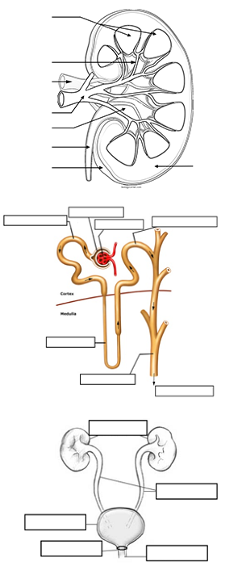
1. List the main functions of the urinary system.

2. Describe the location of the kidneys; identify the kidneys, ureter, urethra and bladder on a diagram

3. Describe and label a kidney (renal pelvis, cortex, medulla, nephron, renal pyramid, hilum)

4. Explain how the kidney helps the body maintain homeostasis?

5. List the vessels associated with the kidney, know their general locations

6. Describe the structure of a nephron, label on a diagram. glomerulus, bowman’s capsule, proximal and distal tubule, loop of Henle, collecting duct

7. Distinguish between filtration, reabsorption and secretion. Where do these processes occur?

8. What type of cells are found within the tubules? What is diffusion?
9. What type of tissue makes up the lining of the bladder?

10. List the substances that make up the urine.

11. What hormone regulates the formation of urine?

12. Explain the process of micturation, which muscle controls the urethral sphincter?

13. Describe disorders that affect the urinary system and how they are treated.

